# Unsupervised Learning Algorithms





Labeled data means there is both X (input variable) and Y (output variable). You train the model using provided X and Y and predict Ys of future Xs.

Unlabeled data means there is only X (Input variable). You don’t have Y.



Model looks at colors, lines, whether it is played using hands or legs. Based on these data, it creates groups of basketballs and soccer balls.



















## K Means Clustering (Exclusive clustering)

### What is clustering?



Examples





### Types of clustering









### How does K-Means clustering work?



<https://www.youtube.com/watch?v=5FpsGnkbEpM>





I decided to have two clusters, k1 and k2. Chose random data points as centroids of these clusters. E.g. c1 and c2 are centroids.

Now, you want to place c3 in one of these clusters. Using Euclidean Distance Formula you can figure out that c3 is more similar to c2. So, c3 will fall in k2.

Now, find out a new centroid by taking average of data points of c2 and c3 in k2.



New centroid in k2 will be (35,900)



Continue these steps for all other data points also.



### Elbow method







<https://www.youtube.com/watch?v=iL1fGv-b9qA>







Initially, start k=2. Take Eucidian distances of datapoints in k1 and k2. Take their sums. This will give you WCSS.

Now take k=3 and find out WCSS.

Now take k=4 and find out WCSS.

And so on.

Then create a plot of Ks and WCSS values. From which point WCSS stops reducing drastically, it will create an elbow like plot. Wherever this elbow is created, take that k as an optimal k.

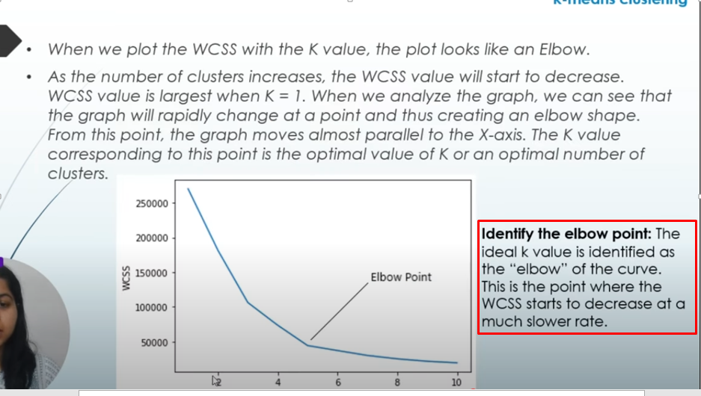













After assigning the data point to a particular cluster, recalculate the centroid (find new centroid value) as explained before.





### How K-Means work?

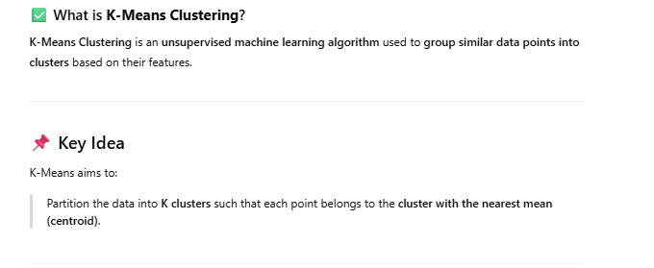

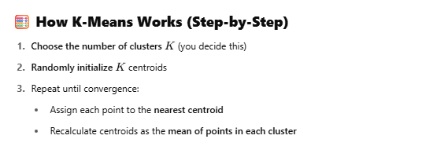

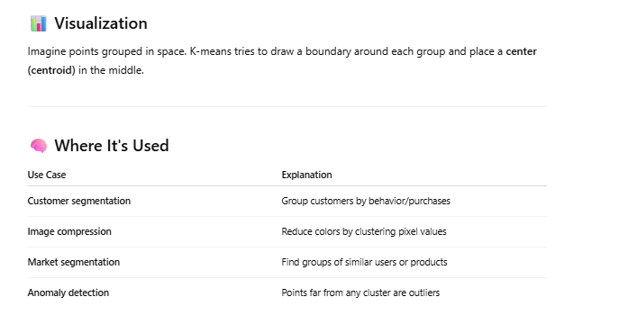

### Code to create clusters and scatter plot

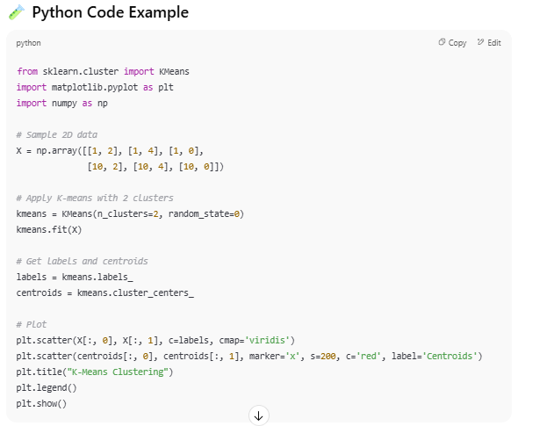

### Elbow method code

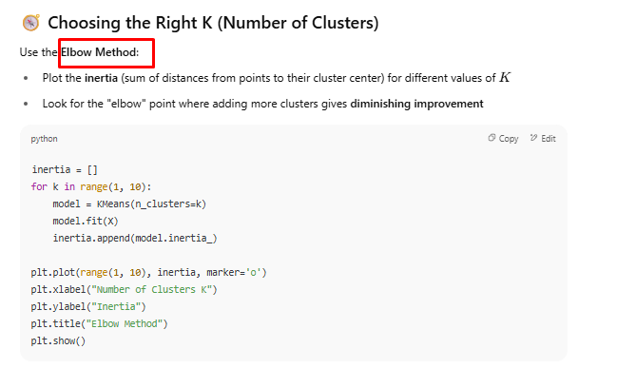

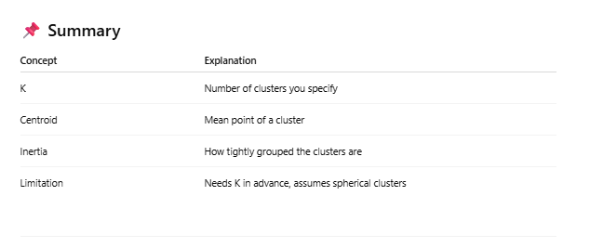

### Giving names to clusters

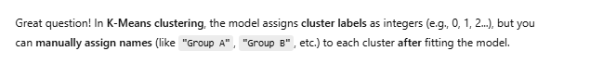

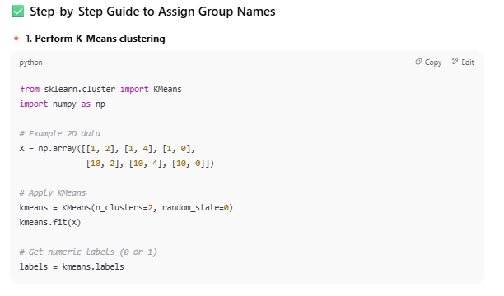

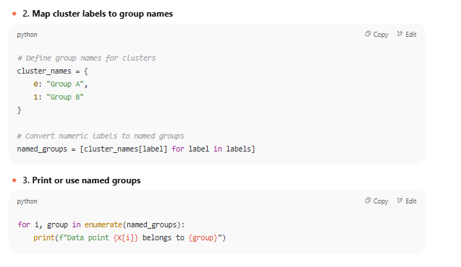

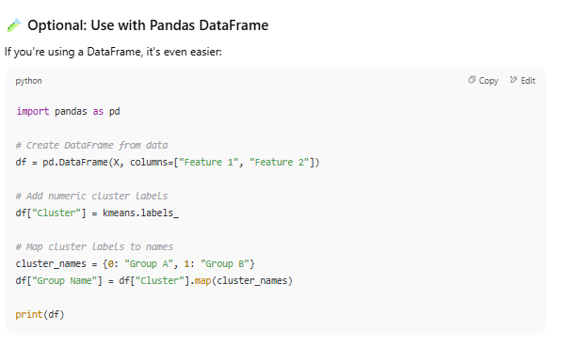

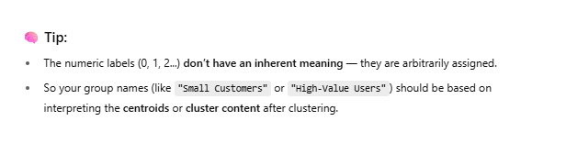

### Prediction using K-means

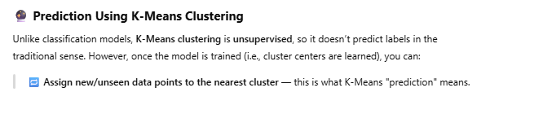

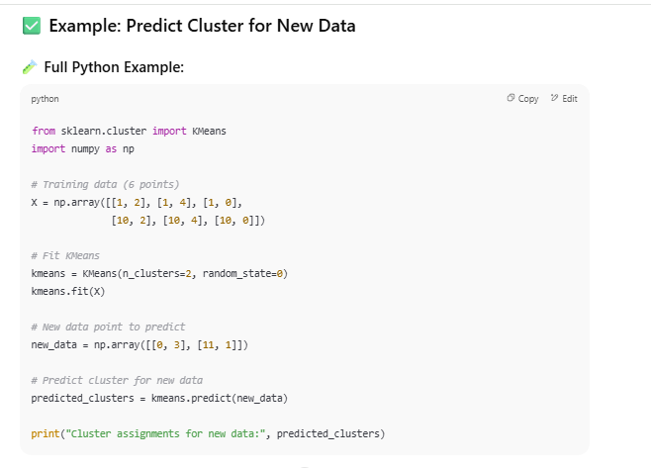

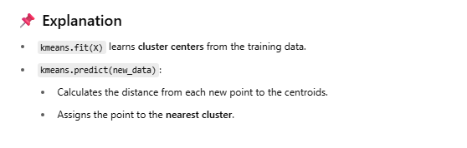

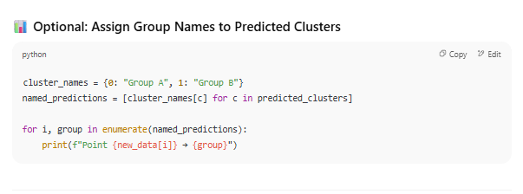

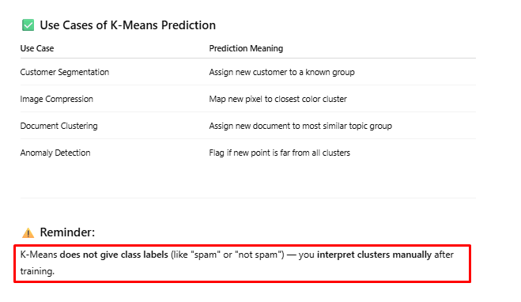

## C-means clustering (Overlapping clusters)

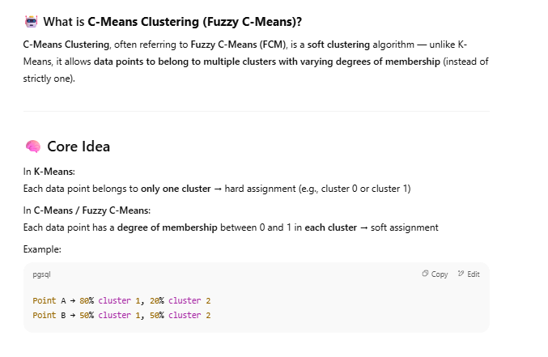

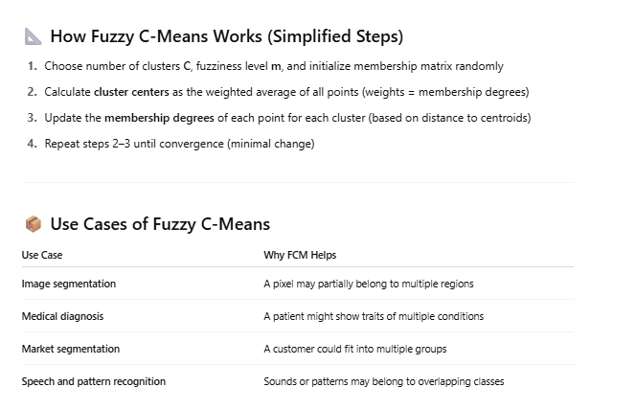

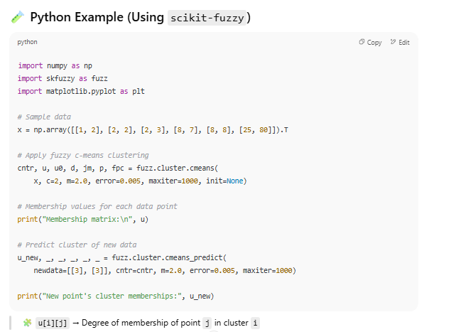

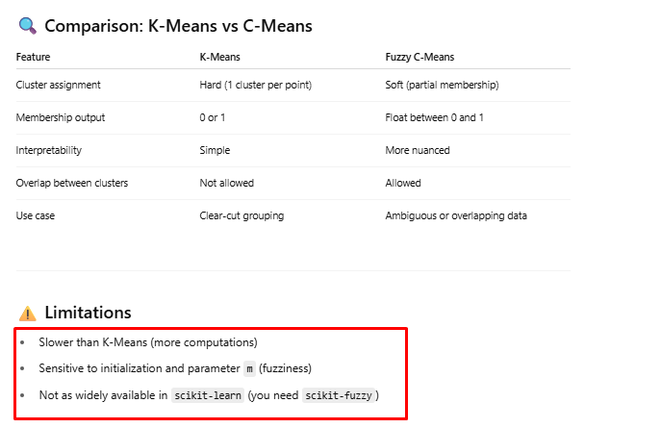

## Hierarchical Clustering



<https://www.youtube.com/watch?v=zxQF8Rmpk1M>









Distance between two data points is small. So, they fall into the same cluster. Distance is calculated using Euclidean Distance formula.

 

When the distance between two data points is more, then they fall into different clusters. Distance is calculated using Euclidean Distance formula.









P5 and P6 are in one cluster(k1). P4 that makes k2 cluster is closer to this cluster k1. So, k2 becomes a parent cluster of k1.

Similarly, P2,P3 and P1 clusters.

At the end, there will be one big cluster that contains all other clusters.

Divisive clustering is opposite of Agglomerative clustering. It goes from top to bottom.















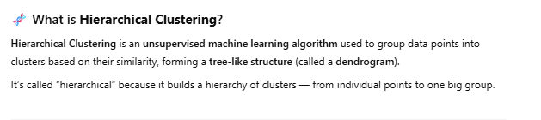

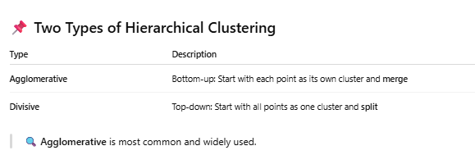

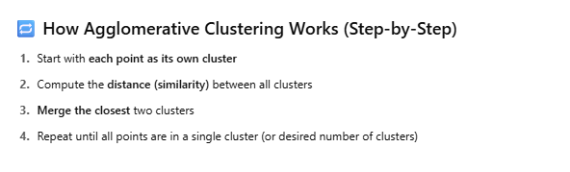

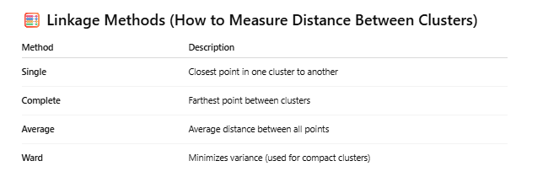

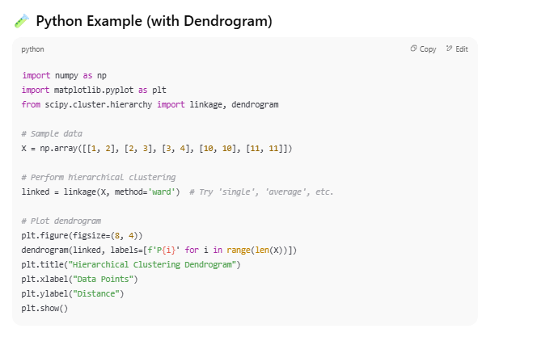

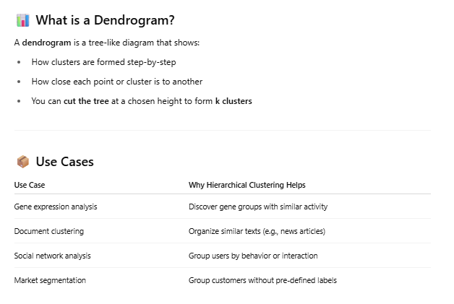

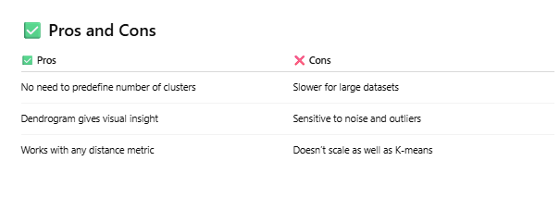

## Principal Component Analysis

First Watch what is overfitting and underfitting

<https://www.youtube.com/watch?v=ICCA3-7a5bw>

Then watch

<https://www.youtube.com/watch?v=FyVCyjna97U&list=PLWPirh4EWFpEjbNicXUZk0wrPBzBlAlU_&index=13>







After doing correlation analysis, we can say that out of all 5 variables, only 3 variable are relevant for predicting the future sells. So, we will reduce the original dataset into the dataset of 3 variables.





You can derive one variable (Principal Component) from many variables to reduce number of variables. Entire process of deriving PC is mentioned in this section later on.



You take the picture from different angles. Whichever angle makes the most people visible in the picture, consider that angle.



Let’s say you are viewing the data points from an angle where data points appear on PC1 line.



You will see this kind of projection of data points on PC1 line.



Take a view from another angle. You will see the projection of data points on PC2 line the way it is shown.





Now, compare PC1 and PC2. In PC1, data points have nice gap and we can see them more clearly than PC2. In PC2, data points are overlapping. So, the information is losing.

So, we will select PC1 for further predictions.









Two Principal components are never taken from the same angle. They are never same.





Calculation of Principle component has 4 important calculations as shown above.

















PC1 and PC2 passes through the mean of data points. PC1 and PC2 are perpendicular to each other.

Very good video explaining how to calculate Principal component <https://www.youtube.com/watch?v=ZtS6sQUAh0c>

Let’s say we want to reduce the dimensionality from 2 variables to 1 variable.

Here, two variables X1 and X2 and their values are given.

First find out their means.



Now, build covariance matrix.



Finding covariance of (x1,x1)



Finding covariance of (x1,x2)



Calculate covariance of (x2,x2)



So, covariance matrix looks like this



Now, find out Eigenvalues of this covariance matrix.

I = identity matrix

0= determinant of Covariant matrix –lambda * I

Identity matrix is like





You will get a Quadratic equation. You will be able to find two values of lambda.

<https://byjus.com/maths/quadratics/>



How to calculate determinant of the matrix?

<https://www.youtube.com/watch?v=7pxMtkBSzfM>



Now, calculate Eigenvectors.

U is an eignvector.





If t=1, then



This is the eigenvector for a given covariance matrix.

When you have to calculate Principal component, you have to take largest lambda value.



If you want next principal component, take the next lambda value and so on.

Here, we want only one principal component, so I will consider lambda1 over here.

We are interested in Unit Eigenvector.

For lambda1, eigenvector looks like e1.



For second principal component, use lambda2. Eigenvector (e2) will be



Now, calculate principal components

Take transpose of calculated eigenvector



Principal components for first eigenvector looks like below.



So, we reduced x1 and x2 to one variable and that is principal components.



Draw e1 and e2.

Now, project the data points on these eigenvectors.



## Anomaly Detection

Anomaly means outliers. Read ‘Outliers’ section in Doc1.











Low temperature is normal during Dec, Jan. But if it happens during May, June, then it is an anomaly within the context of month of the year.



e.g. if one computer goes down in a lab, then it is considered a normal instance. But if all computers go down simultaneously, then it’s a rare instance because of cyber attack or power shutdown.



If you are using a credit card and normally you don’t spend much using your credit card, but on some day there is a big transaction happened on your credit card, then it can be fraud case and bank and customer should be intimated immediately.



Watch

<https://www.youtube.com/watch?v=kqAxfOPlr1U>



When data point takes the shortest path to reach to leaf node in a decision tree of randomly chosen rules based on variables, it is considered as an outlier.



Many decision trees are created and then the average of path distances is calculated to consider a particular data point as an outlier or inlier.



When s(x,n) is closer to 1.0, then that data point is considered an anomaly data point.

















If a distance of a particular data point is farther than distances amongst the other data points, then that data point is considered as a local outlier. K=3 is based on k-nearest neighbors. A data point’s distance will be calculated with 3 nearest neighbors.

## Association Rule







Customers who buy bread, there are 60% chances of them buying jam also.

Customers who buy laptops, they mostly buy laptop bag also.

Shopkeepers try to find association between products and items, so that they can be placed at the right place in the shop.

Shopkeepers can encourage the customers to buy eggs also by putting them near to bread and by giving some sale on it.



This is what market basket analysis is all about.





Association rule is like if then condition. If customer buys Item A, then there is a high probability that he will buy Item B as well in the same transaction. It’s a co-occurrence pattern that comes in the force.

We talked about a simple problem of bread, jam and eggs. But what if there are thousands of data! A data scientist can help you to figure out the association between products and increase your profit.

Association rule mining is all about building the rules.

If the customer buys A, there is a high probability that he would buy B also. This is a single Cardinality.

What if there is a possibility of A->B->C or A->B->C->D also.

Cardinality increases and lots of combinations are found.

If there are thousands of records and variables, there can be thousands of rules also. Well, we do not have create so many rules. We simply need to rely on math of Association Rule Mining.





Support means finding the frequency of buying A and B together. N is total number of transactions.

Confidence means how often A and B were bought together when A was bought.

Lift means if denominator is more than numerator, randomness of A and B buying were more than buying them together.

Lift = confidence/support(B)

Support Frequency of itemset in all transactions  
Confidence Strength of the rule (reliability)  
Lift Indicates correlation (Lift > 1 = strong relationship)









<https://www.youtube.com/watch?v=i5Oyzn3XryY&list=PLm5IZukmvRNmj2eqq9Y0_7GRP_4dozIGZ>









Support = number of transactions that has milk, diapers and beer / number of transactions.

Support=0.4 means 40% of transactions have milk, diapers and beer sold together.



If a transaction contains milk and diapers, what is the probability of it containing beer also?

Confidence=0.67 means 67% of the transactions that contain milk and diapers also contain beer.



Confidence of buying beer together with milk and diapers can be high (here 67%). But what if beer was bought without milk and diapers a lot many times, so that confidence ((milk,diapers)->beer) seems very small against it. If Lift is higher than 1, then the rule of (milk,diapers)->beer is very important.





Frequent datasets means whose support value is greater than threshold value.

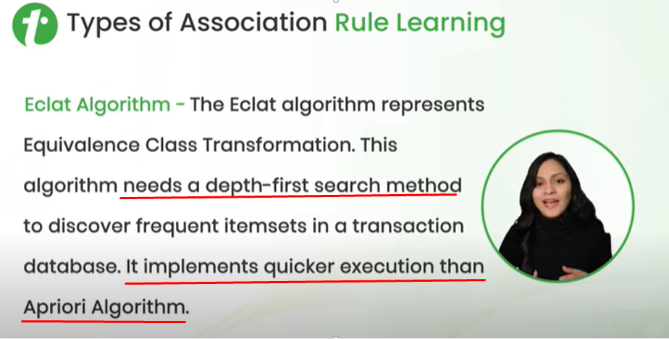

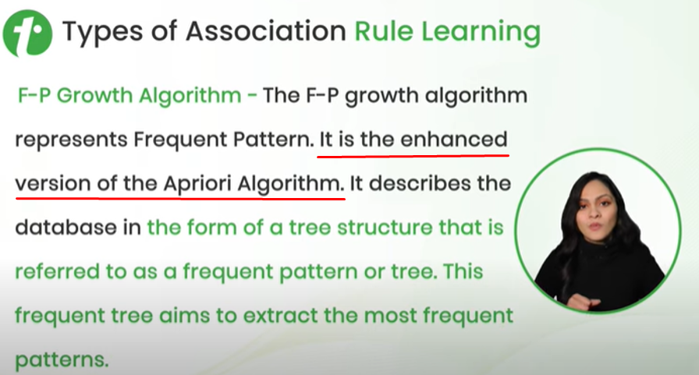

F-P Growth means Frequent Pattern Growth.

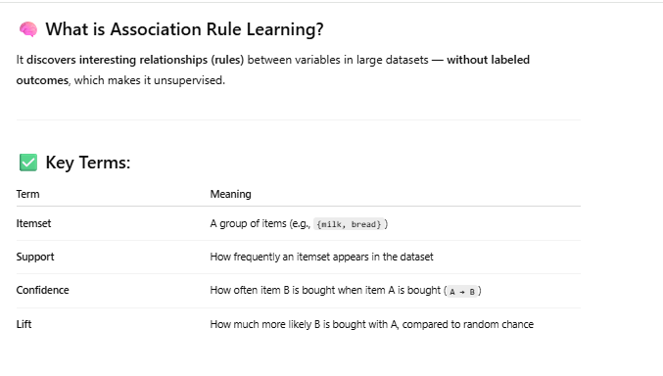

### Apriori Algorithm

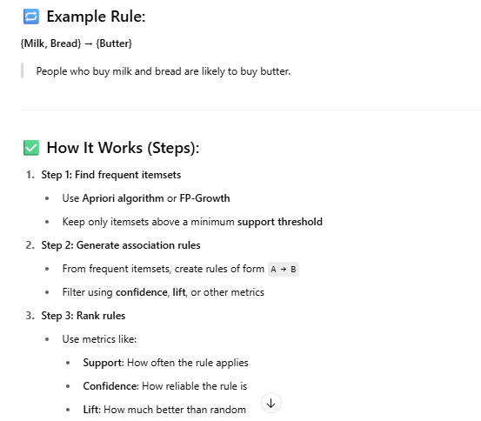

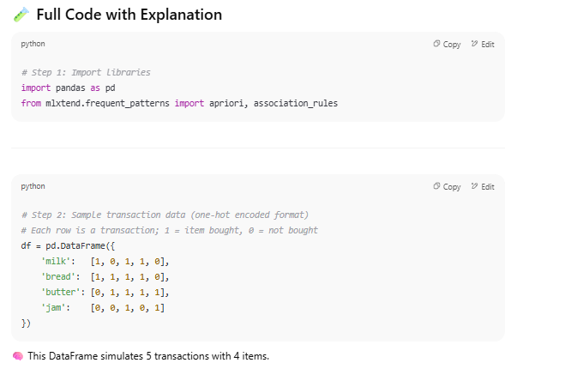

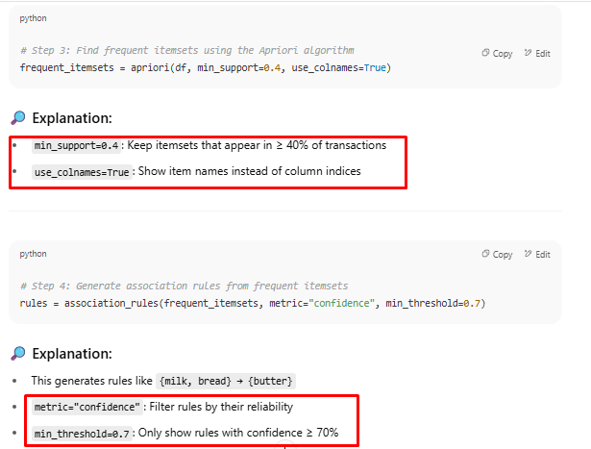

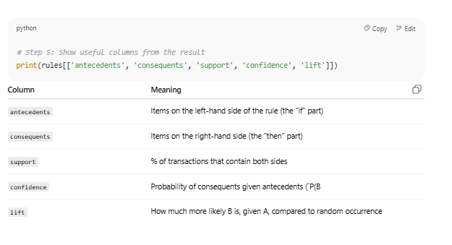

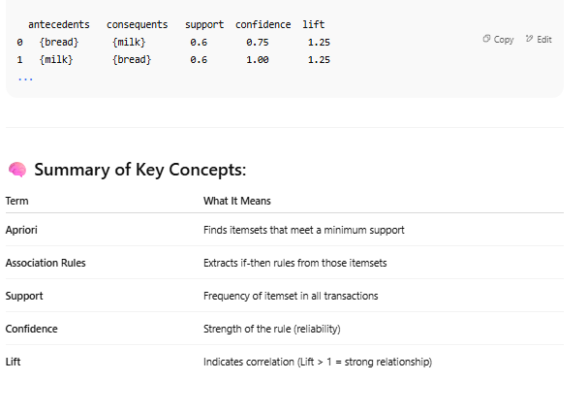

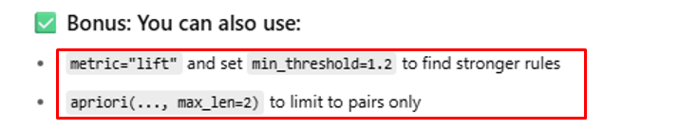

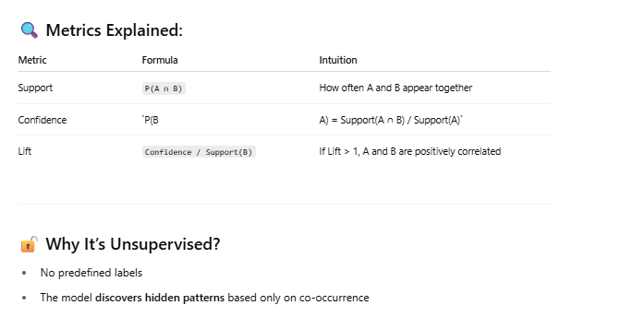

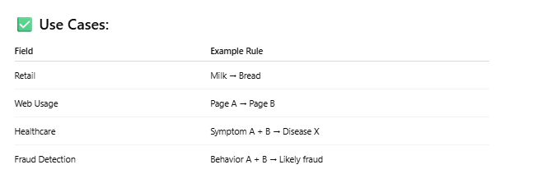

### F-P Growth (Frequent Pattern Growth) Algorithm



It is faster than Apriori algorithm.

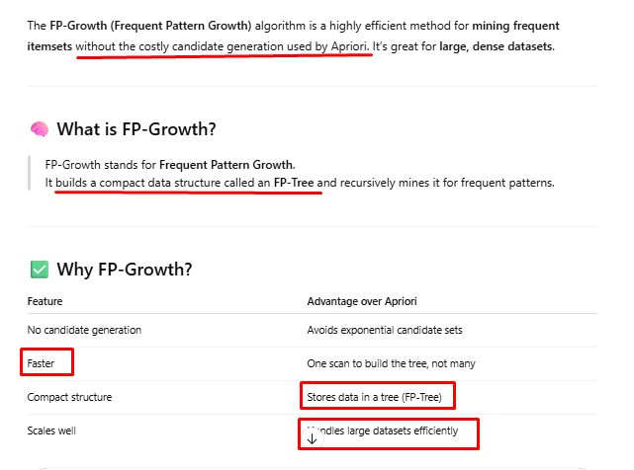

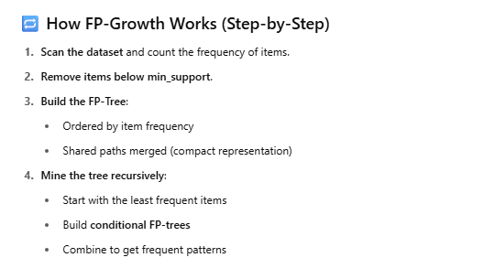

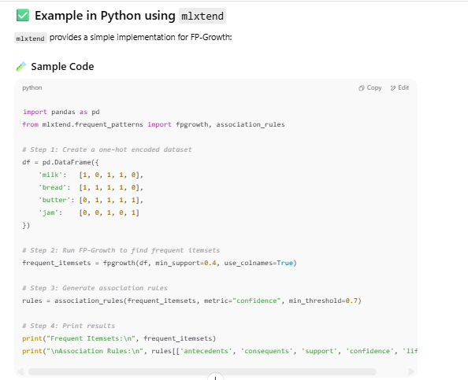

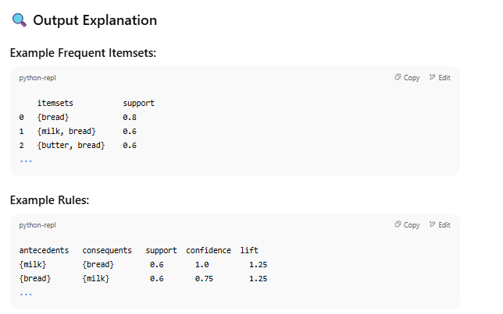

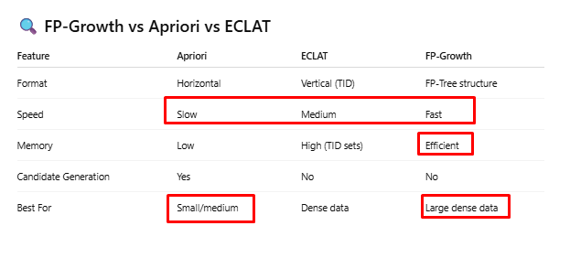

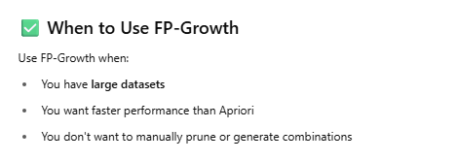

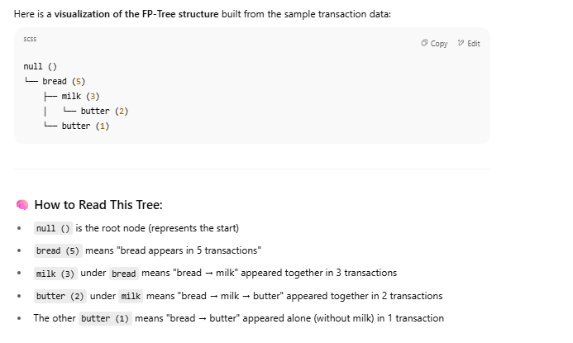

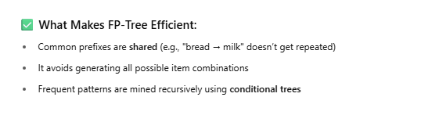

# Reinforcement Learning









Let’s say the agent has to move from point A to point B in a room. Every time, it moves closer to B, it gets +20 points and every time it move away from B, it gets -10 points.









Next time, when agent goes through the room, it already knows that Path 2 is more efficient. So, it will take Path 2.

Another example







Next time, when a child sees candies, he will it that. When he sees candles, he will stay away from that.

Just like this, Reinforcement agent also learns from trial and error.













## Q Learning

<https://www.youtube.com/watch?v=J3qX50yyiU0>

<https://www.youtube.com/watch?v=QRMNPCsnSHk>





Agent takes some action in the environment goes to a new state. It affects the environment. Agent gets the +ve or –ve reward from the environment.















Q table that contains states and actions.







We will use this Q table to trace the best optimal path.



### Q-Learning Formula

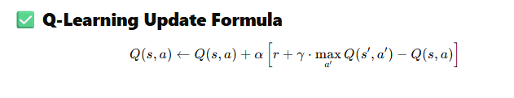

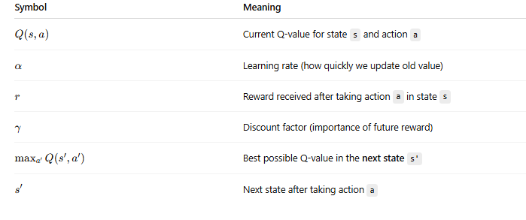

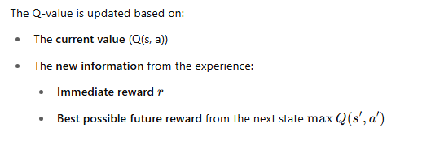

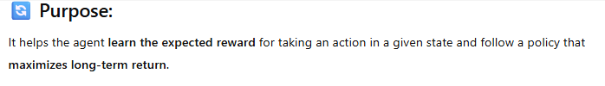

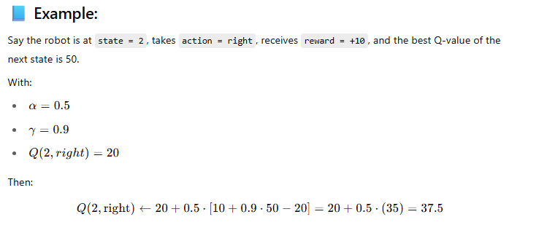

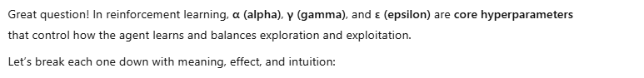

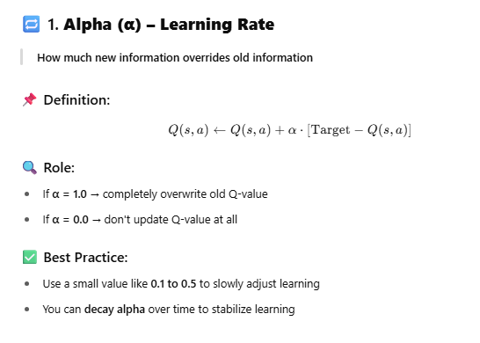

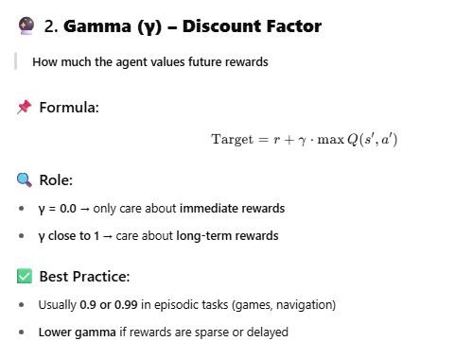

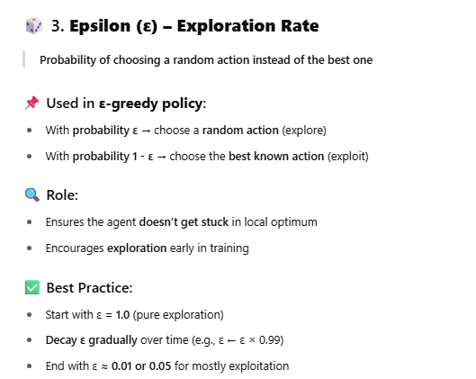

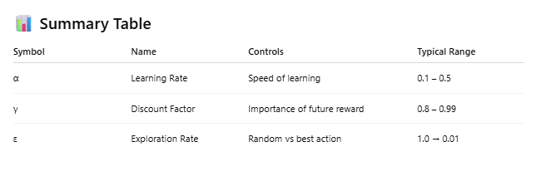

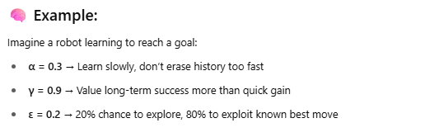

### Rooms and Doors Example



We will consider doors as actions and rooms as states.







Matrix R – Reward table is made of states and actions.

















Let’s start with state 2. Best value is 64.

Next state is 3.

At state 3, best value is 80.

So, next state is let’s say 1

At state 1, best value is 100.

So we reached the goal state.

Path can be 2->3->1->5

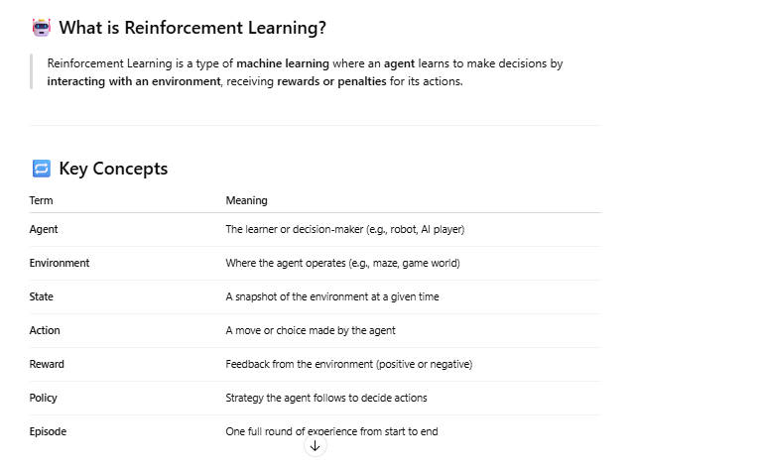

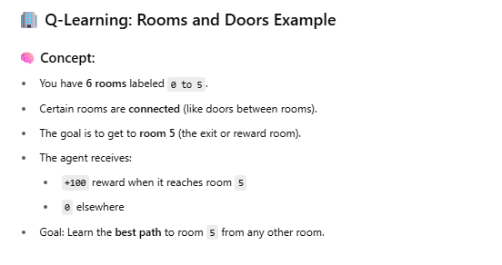

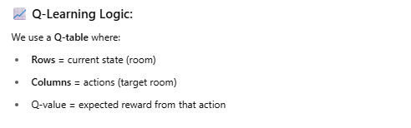

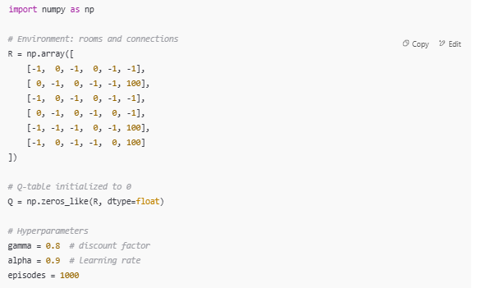

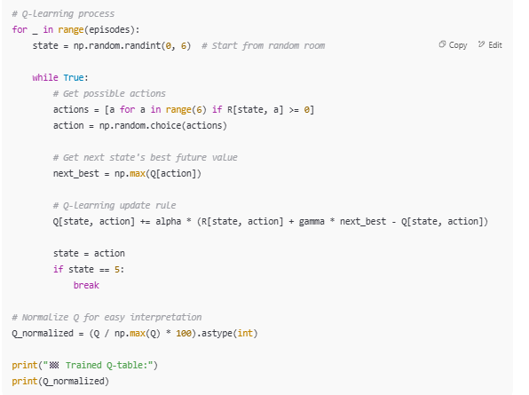

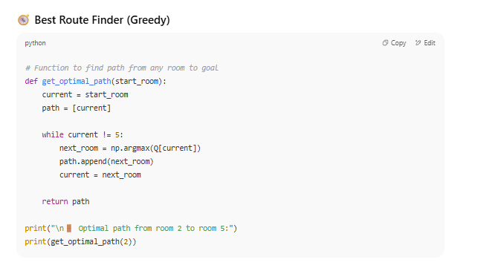

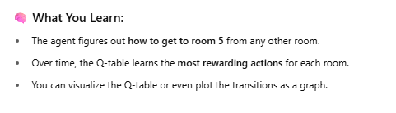

### 4x4 Grid Example

